~~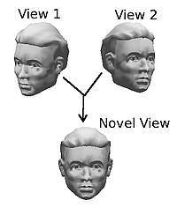~~**~~3d object recognition (homepage bit)~~**

~~For humans, it’s very easy to recognise objects even from varying perspectives but for computers, this is very difficult. One of computer vision’s main goals is to recognise 3D real-world objects and is a subset of AI.~~

~~This requires full 3d model of the object and dedicated hardware which is expensive. Hence, UCL is researching techniques in which a 3D model can be produced by taking many 2D images to generate novel views of the 3d object without the need for a full model.~~

[~~https://www.youtube.com/watch?v=BigrGEvFTJs~~](https://www.youtube.com/watch?v=BigrGEvFTJs) ~~– robo phil tutorial for object recognition~~

**Overview:**

In 1966 Marvin Minsky said, “Connect a TV camera to a computer and get the machine to describe what it sees”. Back then, computer vision relied heavily on edge detection. This is when computers locate sharp contrasts in light intensity to detect object locations as well as their shape, size and presence in the image.

During 2001, the ‘Sliding Window’ method was invented. A window slides along the image categorising each window as ‘object’ or ‘non-object’. Usually used in facial recognition, this was one of the most important successes in object recognition.

Nowadays, there are even more methods for 3D object detection, such as feature-based geometric approaches. This approach works well for objects with distinctive features. The general method for this is pre-capturing a number of fixed views of the object, taking out said distinctive features and then matching them back up to the scene in the recognition process.

**Uses**

3D object recognition is common in every day society, with lots of uses.

Video surveillance & People Counting

This can be used for counting the no. of ppl attending events and festivals. This data is used in statistics. This is difficult as people are non-rigid objects and move fairly quickly outside the frame**.** People also obstruct one another from view and wear a range of clothing styles.

It is also used in speed cameras to detect the speed of vehicles as well as in ‘smart’ pedestrian crossings so traffic lights can change accordingly to the no. of cars and pedestrians.

AR – Augmented Reality

By detecting real-world objects in real time, we can enhance the view by adding CG overlays and graphics. Most of the time, these programs use ‘markers’ such as special images etc to trigger pre-defined CG graphics.

https://virtualrealitypop.com/object-recognition-in-augmented-reality-8f7f17127a7a

**Obstacles:**

As well as expensive, machines have problems with real-time recognition especially if the object is in a different pose (due to the object's position, size, orientation, pose, lighting, etc) than what they have ‘learnt’. It is difficult to imitate the brain’s way of recognising objects with a computer and proves to be the biggest obstacle in computer vision.

**Citation:**Pinto N, Cox DD, DiCarlo JJ (2008) Why is Real-World Visual Object Recognition Hard? PLoS Comput Biol4(1): e27. https://doi.org/10.1371/journal.pcbi.0040027

**Future Directions**

One of the most anticipated consequences of 3D object recognition is 3D printing.

After recognising and making 3D models, we can use these to 3D print products. At the moment, 3D printing is too slow for mass production but as seen with Adidas, 3D modelling and printing is becoming more apparent in the market.

<https://www.economist.com/news/briefing/21724368-recent-advances-make-3d-printing-powerful-competitor-conventional-mass-production-3d>

Medical Use:

Complex 3D models can be printed out that match a patients’ unique condition and anatomy (patient-specific) created from the patient’s imaging data – some devices are more general purpose and can be mass produced.

Examples include implants and external prosthetics such as arms and hands. There is undergoing research to be able to 3D print organs such as hearts and livers but it is still in early stages.

Here’s a FDA Powder Bed Fusion Printer pic:

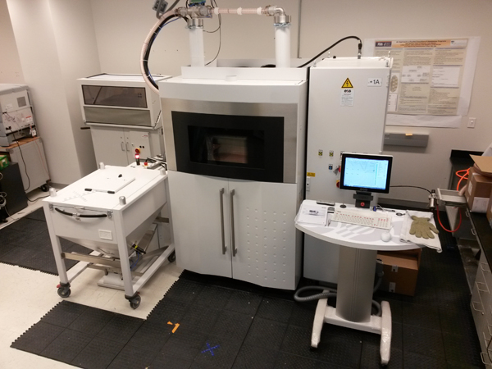

https://www.fda.gov/MedicalDevices/ProductsandMedicalProcedures/3DPrintingofMedicalDevices/ucm500539.htm

Currently, this publication talks about Image Quality Transfer (IQT) from UCL researchers. IQT uses machine learning to transfer one-off high quality images from experimental medical imaging devices to the more common lower quality machines. The machines can use this information to then improve low quality images by enhancing image resolution.

Alexander, D.C., Zikic, D., Ghosh, A., Tanno, R., Wottschel, V., Zhang, J., ...Zhang, H. (2017). [Image quality transfer and applications in diffusion MRI..](https://iris.ucl.ac.uk/iris/publication/1212936/1) *Neuroimage*, doi:10.1016/j.neuroimage.2017.02.089

*Criteria:*

*• An overview of the history of the research area.*

*• Some of the key researchers, publications and results.*

*• The impact of at least some of the sub-areas you have included, showing how the results of the research have been used, and the effect it has had on the world and society.*

*• Possible future directions of the research area.*

*• While the website is not exclusively about the research done at UCL, highlight at least some of the current research being done here.*

*• Links and references to further information and cited work.*

*• Video and images can be used, but always respect copyright and cite or reference sources.*

*• Remember that copy and pasting other people’s work without references, so that it looks like your creation, is plagiarism.*